Section A
- This question is about gas pressure.
- Which is the correct description of how particles move in a gas?

Tick (✓) one box.

At random speeds in the same direction | 
At random speeds in random directions

At the same speed in the same direction
At the same speed in random directions
- Gas pressure is exerted when particles collide with a surface of a container. Explain what this means.

___________________________________________________________________________________
- What is the relationship between gas pressure and temperature (when the volume of the gas stays the same)?

Tick (✓) one box.
They are directly proportional
They are indirectly proportional
They are inversely proportional
- Which property of gas particles is the temperature related to?

___________________________________________________________________________________
- What is the relationship between gas pressure and volume (when the temperature of the gas stays the same)?

Tick (✓) one box.
They are directly proportional
They are indirectly proportional
They are inversely proportional

Section B
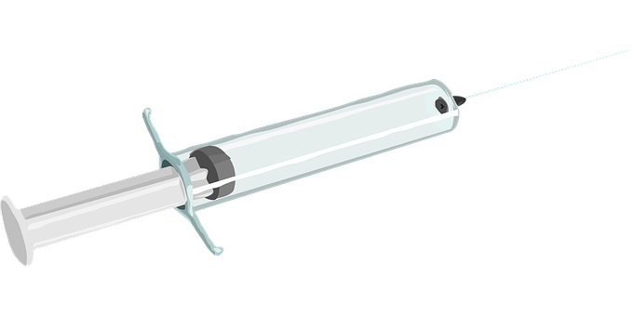
- The image shows a syringe that contains air. The syringe is placed into an ice bath, which decreases the temperature of the air in the syringe.
- What would happen to the average kinetic energy of the particles when the temperature is decreased?

______________________________________________________
- Explain why the average kinetic energy is used.

______________________________________________________
______________________________________________________
- What would happen to the average speed of the gas particles if the temperature decreased?

___________________________________________________________________________________
- What would happen to the gas pressure inside the syringe if the temperature decreased?

___________________________________________________________________________________
- The plunger of the syringe is pulled outwards. Why does air move into the syringe as the plunger is pulled outwards?

___________________________________________________________________________________
___________________________________________________________________________________

- The syringe is then placed into a hot water bath. Complete the table by ticking the correct box to identify what would happen to the following quantities.

 | Increases | Decreases | Stays the same
Mass of the gas
Density of the gas
Average speed of particles of gas
Pressure exerted by the gas
- The relationship between the pressure of a gas and its volume is given by the equation:

$$Pressure × volume=constant$$

For this equation to apply, what two properties of the gas must stay the same?

1._______________________________________________________________________________

2._______________________________________________________________________________

- Describe the effect of increasing the temperature on the pressure of a gas. Explain your answer.

___________________________________________________________________________________
___________________________________________________________________________________
___________________________________________________________________________________

- Describe the effect of increasing the volume on the pressure of a gas. Explain your answer.

___________________________________________________________________________________
___________________________________________________________________________________
___________________________________________________________________________________

- Use the following equation to answer this question:
p₁ x V₁ = p₂ x V₂
- A gas sample has a volume of 22 m³ at a constant temperature.
What is the new volume if the pressure changes from:
- 5 Pa to 10 Pa?
- 81 Pa to 124 Pa?
- If the temperature remains constant, calculate the new pressure if a volume of gas of:
- 1.5 m³ at a pressure of 120 Pa changes to 0.5 m³.
- 0.02 m³ at a pressure of 72000 Pa changes to 0.6 m³.

Section C

- A group of scientists were investigating the behaviour of air particles at different temperatures. They used the same container throughout, which had a volume of 1 m³. They cooled the air from 22 ºC to 0 ºC.
- Describe and explain what would happen to the particles of air in the container.
- Describe and explain what would happen to the pressure within the container.
- Is air an element, a compound or mixture? Explain your answer.
- Water within the air froze at 0 ºC. The specific latent heat of fusion of water is 330 kJ/kg and the change in internal energy of the water was 0.85 kJ.
Calculate the mass of ice that formed.
Use the equation: $ΔE= m L$
- The air also contains oxygen and nitrogen. The melting and boiling points of each substance is shown in the table.

 | Melting point (ºC) | Boiling point (ºC)
Oxygen | -218 | -183
Nitrogen | -210 | -195

The apparatus the scientists were using allowed them to cool the air to -190 ºC. What state would the water, the oxygen and the nitrogen be in at -190 ºC?

